Coupled-LSTM을 이용한
국내 환율 예측에 관한 연구
A Study on the Prediction of Domestic Exchange Rate Using Coupled-LSTM
Dae Kyem Kim*
* SUNGKYUNKWAN Department of Data Science Convergence (TEL : 010-2923-1447; E-mail: rlaeorua24@naver.com)
Abstract Domestic exchange rate research was centered on short- and long-term forecasts using a classic exchange rate model (Park and Park, 2015). In While stock price analysis using artificial intelligence techniques is actively conducted, most exchange rate prediction studies are conducted in classical models. The research on exchange rates is essential and important in export-oriented and trade-oriented countries like Korea but has not been studied with the latest techniques such as deep learning. Therefore, this paper tries to carry out the study of exchange rate prediction by using artificial intelligence deep learning techniques DNN(Deep Neural Network) and LSTM( Long Short-Term Memory). Artificial intelligence technologies are proving useful in predicting and classifying financial variables, and it is self-evident that exchange rate research is important in the export-oriented Korean environment. However, domestic exchange rate forecasting studies are not active and new methods are not being applied. As computing power grows rapidly, there is no research on exchange rate prediction using various artificial neural network techniques that are being re-examined. This study aims to contribute to the absence of the study subject by conducting a won (KRW)/dollar (USD) exchange rate prediction study centered on DNN and LSTM.

Keywords Exchange Rate, Deep Learning, LSTM(Long Short-Term Memory), DNN(Deep Neural Network), Prediction, Machine Learning,

- Introduction

Korea's dependence on exports and imports is a country heavily dependent on trade, with the proportion of exports and imports to GDP accounting for nearly 70 percent as of 2019. In Korea, which relies heavily on exports and imports, the won/dollar exchange rate is a very important factor in the price competitiveness of export goods and a key factor directly affecting the prices of imported goods such as raw materials. At the same time, it is a variable that plays a role in maintaining the stability of the Korean stock market and maintaining the stability of the investment sentiment of foreigners/institutions. Morgan Stanley Capital International (MSCI) of the United States classified Korea as an emerging market, and the main reason is the lack of exchangeability of the won. As such, Korea has a different financial, securities, and capital market environment than other developed countries, so the decision of exchange rates can also have special characteristics. In particular, since the 1997 financial crisis, the study of forecasting exchange rates in the volatile exchange rate has been limited to difficulties in securing samples. Thus, while predictions of exchange rates worldwide have been studied a lot, Korea's recent research on the won-dollar exchange rate has been conducted on a limited basis.
Due to the development of artificial intelligence technology, academic circles have been actively conducting research on predicting financial variables using artificial intelligence techniques. Among them, the DNN and LSTM techniques to be used in this study are analysis techniques that are widely used and recognized for their usefulness. DNN, which is widely used to predict financial variables in and out of the country, has been used in classification-based financial market forecasting research (Dixon et at, 2017). In addition, LSTM is widely used when the time-series characteristics of financial variables are important, typical of the LSTM study in Fischer et al.(2018) for the analysis of financial time-series characteristics. In addition, Cao (2020) conducted a USD/CNY exchange rate prediction study using deep LSTM, while Cocianu and Avramescu (2020) conducted a study that demonstrated the excellence of the model by combining LSTM with the NARX model. In line with this trend, a study of forecasting financial variables using deep learning techniques has been carried out in Korea, with a typical example of a forecast of share prices using LSTM and circular neural network techniques (Shin Dong-ha et al., 2017). However, domestic research is focused on stock price prediction research, and there has been no research on exchange rate prediction using LSTM in Korea yet.

- Related Work

Exchange rates have a profound effect on trade between countries and are a very important financial variable. In particular, it affects the prices of various financial and real assets, including stocks, bonds and real estate, and it is a variable that affects the rise and fall of many financial variables. Korea is vulnerable to foreign exchange risk because it is a small open economy that is highly dependent on exports and is not enough to take the lead in the international market. In these circumstances, research on exchange rates is essential, and research on currency forecasts is very important.
Traditional currency forecasts were made using a metering economy model. One of the representative models of the metering economy is the ARCH (Automatic Conditional Heterosis: Engle, 1982) model of Engle. However, the quantitative economic model revealed its limitations due to the volatility of various variables present in the market. Meese and Rogoff (1983) argued that it was quite difficult to improve the Random Walk model above a certain level, taking into account macroeconomic fundamentals. Since then, Meese and Rogoff (1987) have published studies showing that the statistical model of exchange rate forecasting cannot perform better than the random work model, and there has been a 'no use' in the academic world for currency forecasting. Later, in an effort to overcome the limitations of the random work model and the quantification model, Clarida and Taylor (1997) used the period structure of the forward exchange premium, vector error correction model to provide improved predictive power, and Jung (2004) conducted a won/dollar prediction study in the same way. Kim (2000) conducted a study to predict exchange rates with state-level input variables and data and monthly input variables and had superior performance compared to the existing metering economy model. However, because qualitative factors, which are the limitations of the metering economic model, cannot be used as variables and the size of available data is relatively small, Varian (2014) argued for the need for a powerful tool to handle vast amounts of unprocessed data.

- Method

3.1 Proposed model
Trend prediction using Multi Channel LSTM combined Daily LSTM of opening price, high price, low price, closing price with Weekly LSTM of opening price, high price, low price, closing price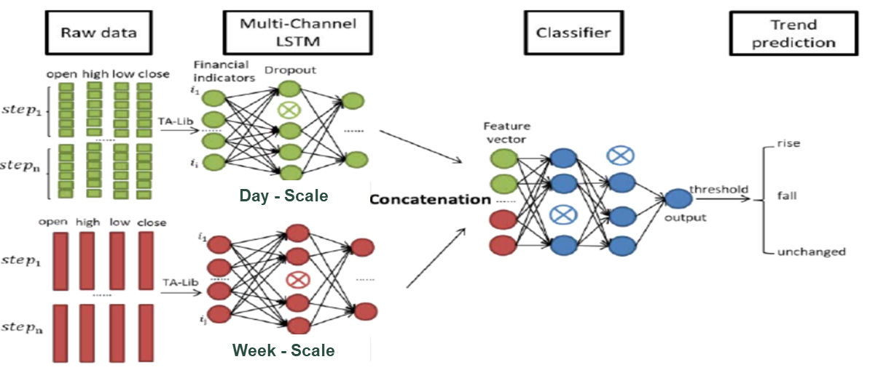
Fig. 1. Trend prediction using Multi Channel LSTM

3.2 Future Research Model
The exchange rate and exchange rate impact factors (international balance of payments, won interest rate, dollar interest rate, credit risk interest rate, exchange rate fluctuation of trading partners) are divided into market variables and macro variables and analyzed by coupled-LSTM.
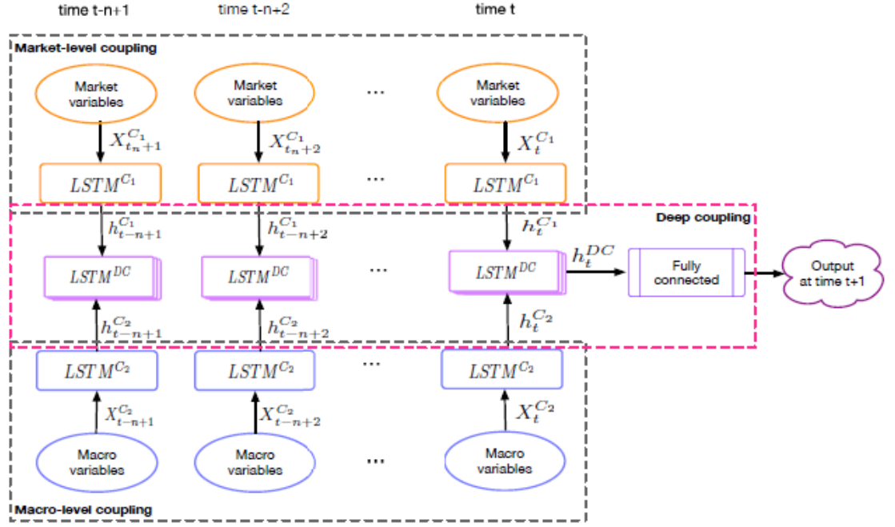
Fig. 2. Future Research Model

- Conclusion
For that reason, the Republic of Korea is a small, open economy that is greatly influenced by a powerful country with leadership. Therefore, the won/dollar exchange rate is one of the important macro measures to explain the economic situation in Korea.
Korea's won-dollar exchange rate has become more volatile since it was converted into a 'full-electronic floating exchange rate system.' Therefore, domestic foreign exchange policy authorities and financial officers need more accurate and diverse information to manage the recovery risk.
The study of exchange rate prediction was much preceded by the traditional method of metering economy model. However, the metering economy model suffered from variable variability problems. For this reason, research on exchange rates has not been active in Korea since the 2000s.
Global exchange rate research has gone through a lot of ups and downs. To effectively predict exchange rate fluctuations, we need tools to handle vast amounts of data. In Korea, there is no research on applying LSTM, which is known to be useful for time series analysis, to exchange rates.
With the won/dollar exchange rate data collected, it is possible to predict trends and closing prices the next day using AI-based deep learning and LSTM, and the forecast rate is about 70%.

Reference

[1] C. Lee, C. Chang and F. Hwang(2019), "Currency Exchange Rate Prediction with Long Short-Term Memory Networks Based on Attention and News Sentiment Analysis," 2019 International Conference on Technologies and Applications of Artiﬁcial Intelligence (TAAI), Kaohsiung, Taiwan, pp. 1-6.
[2] W. Cao, W. Zhu, W. Wang, Y. Demazeau and C. Zhang(2020), "A Deep Coupled LSTM Approach for USD/CNY Exchange Rate Forecasting," in IEEE Intelligent Systems.
[3] Cocianu, C., & Avramescu, M. (2020). The use of LSTM neural networks to implement the NARX model. A case study of EUR-USD exchange rates. Informatica Economica, 24(1), 5-14.
[4] Ahn. J. J., Byun, H. W., Oh, K. J. and Kim, T. Y. (2012). Using ridge regression with genetic algorithm to enhance real estate appraisal forecasting. Expert Systems with Applications, 39, 8369-8379.
[5] Jeong. K. H. (2017). Quantile causality from dollar exchange rate to international oil price. Journal of the Korean Data & Information Science Society, 28, 361-369.
[6] Kim, S. H. (2000). Establishment of Optimal Artificial Neural Network Model and Exchange Rate Prediction Performance Analysis. Journal of Money and Finance, 14, 57-85.
[7] 김영철, 이현준, 김지우, 안재준. (2018). 스왑포인트 결정요소를 이용한 머신러닝 기반의 원/달러 환율 예측 모형에 관한 연구. 한국데이터정보과학회지, 29(1), 203-216.ience Society, 20, 655-660.

